MSE1000 - 2000 chip devices comparision
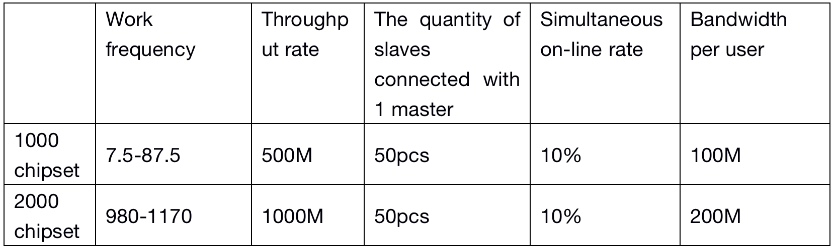
MTK - QCA chip devices compairison
